**Importing Libraries**

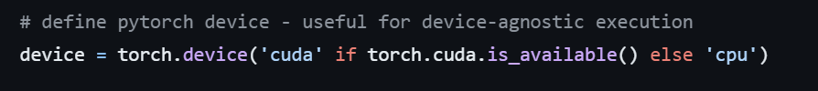**Device Definition**

Explanation: This line defines the device for tensor computations based on GPU availability. It uses CUDA (GPU) if available, otherwise falls back to CPU.

**Model Parameters**

Explanation: These are parameters for training such as the number of epochs, batch size, learning rate, image dimensions, number of classes, and device IDs for multi-GPU training.

**Data and Output Directories**

Explanation: These variables define the input data directory, training image directory, output directory, log directory for Tensorboard logs, and directory for saving model checkpoints.

**Model Definition (AlexNet)**

Explanation: This part defines the AlexNet model using the **nn.Module** class. It consists of convolutional layers, activation functions, local response normalization, max-pooling layers, and fully connected layers.

**Initialization of Model**

Explanation: This block contains the main script. It initializes necessary components like the summary writer for Tensorboard, the AlexNet model, dataset, data loader, optimizer, learning rate scheduler, and starts the training loop.

**TensorboardX Summary Writer**

Explanation: This initializes a summary writer for Tensorboard, which will be used to write logs for visualization during training.

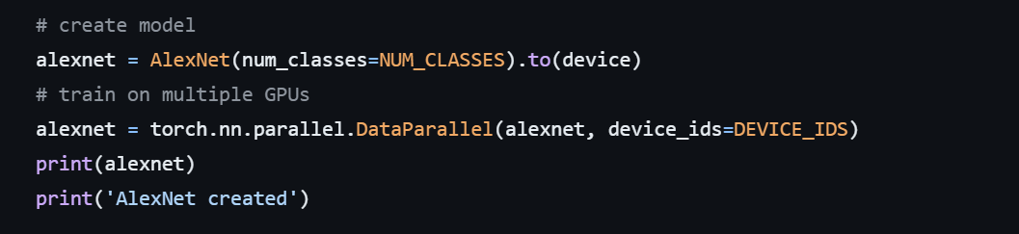**Model Initialization and Parallelization**

Explanation: It creates an instance of the AlexNet model and moves it to the specified device (GPU or CPU). If multiple GPUs are available, it parallelizes the model across them.

**Dataset and DataLoader Creation**

Explanation: These lines create the dataset and data loader for training images. It applies transformations such as resizing, cropping, normalization, and converts images to tensors.

**Optimizer Definition**

Explanation: This line initializes the Adam optimizer for updating the model parameters during training.

**Learning Rate Scheduler**

Explanation: It sets up a learning rate scheduler, which adjusts the learning rate during training. Here, it reduces the learning rate by a factor of 0.1 every 30 epochs.

**Training Loop**

Explanation: This loop iterates over the specified number of epochs and performs training. Within each epoch, it iterates over batches of data, calculates loss, updates model parameters, logs training information, and saves model checkpoints.

**Checkpoint Saving**

Explanation: This line saves the model's current state, including epoch, optimizer state, model parameters, and random seed, to a checkpoint file.